% Roll No: 207

% Batch: C3

% Date: 20-04-2023

% Name: Mohanish Khambadkar

% Assignment 6

function [y] = fun(x)

%main function

y= 0.2+25\*x-200\*x^2+675\*x^3-900\*x^4+400\*x^5;

end

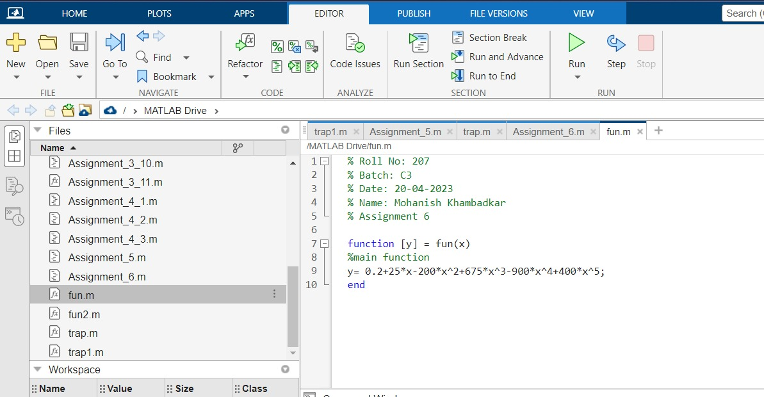

function [y2] = fun2(x)

y2=0.2\*x+(25\*x^2)/2-(200\*x^3)/3+(675\*x^4)/4-(900\*x^5)/5+(400\*x^6)/6;

end

